Denali National Park
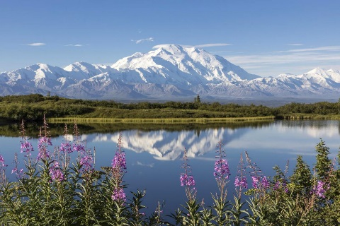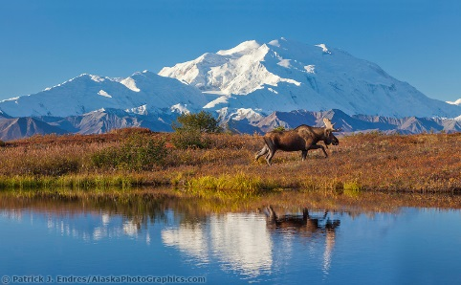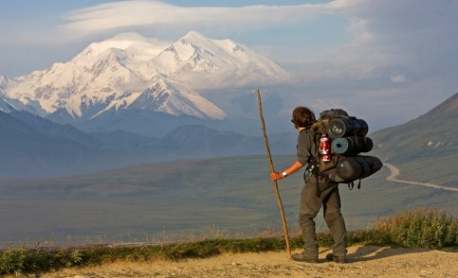

What is the Denali National Park?
Denali National Park and Preserve is an American national park and preserve located in Interior Alaska, centered on Denali, the highest mountain in North America.
The park and contiguous preserve encompass 6,045,153 acres (9,446 sq mi; 24,464 km2) which is larger than the state of New Hampshire.

Facts About the Mountain Range:
- Human habitation in the Denali Region extends to more than 11,000 years before the present, with documented sites just outside park boundaries dated to more than 8,000 years before present.
- Naming Controversy - The word Denali means "the high one" in the native Athabaskan language and refers to the mountain itself. The mountain was named after newly elected US president William McKinley in 1897 by local prospector William A. Dickey. The United States government formally adopted the name Mount McKinley after President Wilson signed the bill creating Mount McKinley National Park into effect in 1917. In 1980, Mount McKinley National Park was combined with Denali National Monument, and the Alaska National Interest Lands Conservation Act named the combined unit the Denali National Park and Preserve. At that time the Alaska state Board of Geographic Names changed the name of the mountain to Denali. However, the U.S. Board on Geographic Names did not recognize the change and continued to denote the official name as Mount McKinley. This situation lasted until Aug. 30, 2015, when President Barack Obama directed Secretary of the Interior Sally Jewell to rename the mountain to Denali.
- Denali’s elevation is 20,310 feet.
- Denali National Park and Preserve is located in an area of intense tectonic activity. Over the past millions of years, exotic terranes in the Pacific Ocean have been moving toward the North American landmass and accreting, or attaching, to the area that now makes up Alaska.
- The oldest rocks in the park are part of the Yukon-Tanana terrane. They originated from ocean sediments deposited between 400 million and 1 billion years ago.
- Glaciers cover about 16% of the 6 million acres of Denali National Park and Preserve.
- Climate: The north and south side of the Alaskan Range have a completely different climate. The Gulf of Alaska carries moisture to the south side, but the mountains block water to the north side. This brings a drier climate and huge temperature fluctuations to the north. The south has transitional maritime continental climates, with moister, cooler summers and warmer winters.

Denali Wildlife

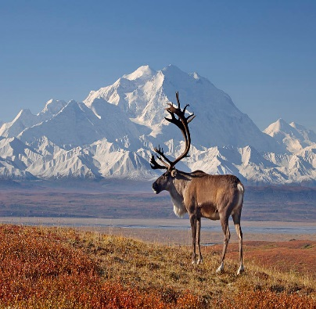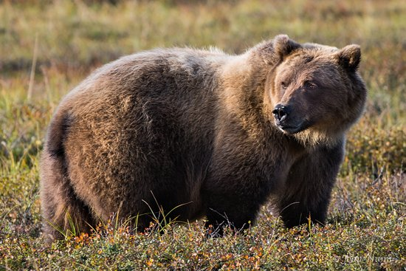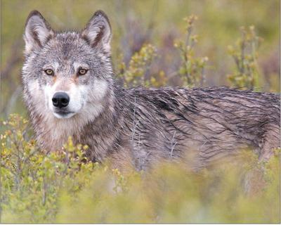
Caribou Grizzly Bear Wolf

Denali is home to a variety of North American birds and mammals, including an estimated 300-350 grizzly bears on the north side of the Alaska Range (70 bears per 1000 square miles) and an estimated 2,700 black bears (334 per 1,000 square miles). As of 2014, park biologists were monitoring about 51 wolves in 13 packs (7.4 wolves per 1,000 square miles), while surveys estimated 2,230 caribou in 2013, and 1,477 moose in 2011.

