India
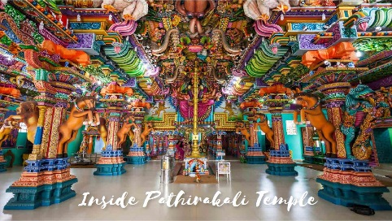

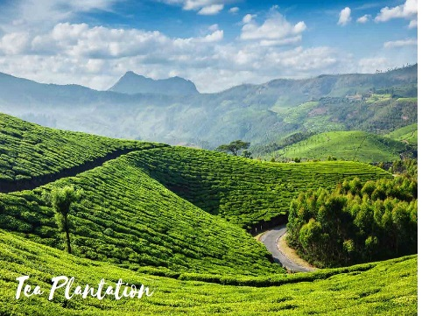

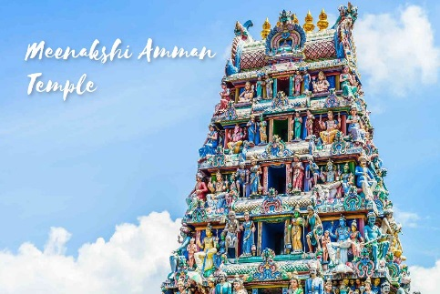

India is a country in South Asia. It is the second-most populous country, the seventh-largest country by area, and the most populous democracy in the world.

Facts About India:
- Modern humans arrived on the Indian subcontinent from Africa no later than 55,000 years ago.
- By 1200 BCE, an archaic form of Sanskrit, an Indo-European language, had diffused into India from the northwest, unfolding as the language of the Rigveda, and recording the dawning of Hinduism in India.
- By 400 BCE, stratification and exclusion by caste had emerged within Hinduism, and Buddhism and Jainism had arisen, proclaiming social orders unlinked to heredity.
- British crown rule began in 1858. After World War I, in which approximately one million Indians served, a new period began. It was marked by British reforms but also repressive legislation, by more strident Indian calls for self-rule, and by the beginnings of a nonviolent movement of non-co-operation, of which Mohandas Karamchand Gandhi would become the leader and enduring symbol. During the 1930s, slow legislative reform was enacted by the British; the Indian National Congress won victories in the resulting elections.The next decade was beset with crises: Indian participation in World War II, the Congress's final push for non-co-operation, and an upsurge of Muslim nationalism.
- India's telecommunication industry, the world's fastest-growing, added 227 million subscribers during the period 2010–2011, and after the third quarter of 2017, India surpassed the US to become the second largest smartphone market in the world after China.
- The 2011 census reported the religion in India with the largest number of followers was Hinduism (79.80% of the population), followed by Islam (14.23%); the remaining were Christianity (2.30%), Sikhism (1.72%), Buddhism (0.70%), Jainism (0.36%) and others[m] (0.9%).

Taj Mahal

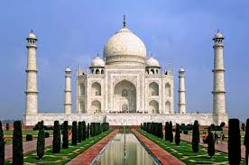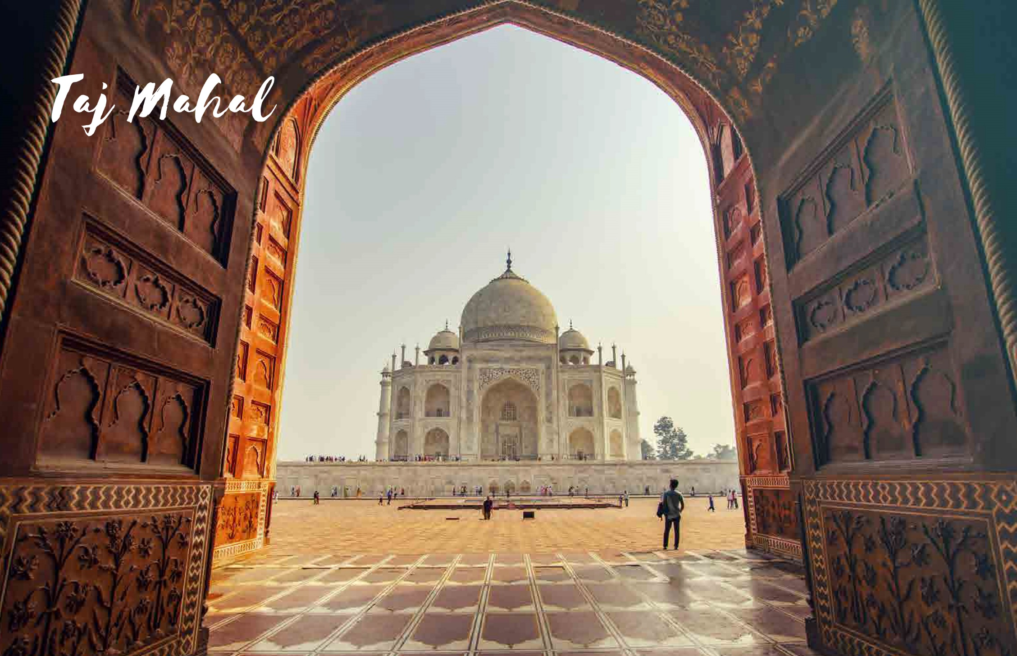
The Taj Mahal, also known as the Crown of the Palace' is an ivory-white marble mausoleum on the southern bank of the river Yamuna in the Indian city of Agra. It was commissioned in 1632 by the Mughal emperor Shah Jahan (reigned from 1628 to 1658) to house the tomb of his favourite wife, Mumtaz Mahal; it also houses the tomb of Shah Jahan himself. The tomb is the centerpiece of 42-acre complex, which includes a mosque and a guest house, and is set in formal gardens bounded on three sides by a crenellated wall.
Construction of the mausoleum was essentially completed in 1643, but work continued on other phases of the project for another 10 years. The Taj Mahal complex is believed to have been completed in its entirety in 1653 at a cost estimated at the time to be around 32 million rupees, which in 2020 would be approximately 70 billion rupees (about U.S. $916 million). The construction project employed some 20,000 artisans under the guidance of a board of architects led by the court architect to the emperor, Ustad Ahmad Lahauri.
The Taj Mahal was designated as a UNESCO World Heritage Site in 1983 for being "the jewel of Muslim art in India and one of the universally admired masterpieces of the world's heritage". It is regarded by many as the best example of Mughal architecture and a symbol of India's rich history. The Taj Mahal attracts 7–8 million visitors a year and in 2007, it was declared a winner of the New 7 Wonders of the World (2000–2007) initiative.

