Yosemite National Park
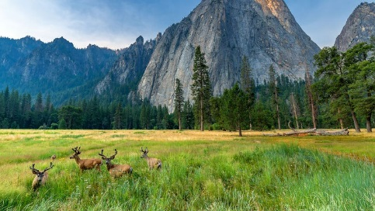

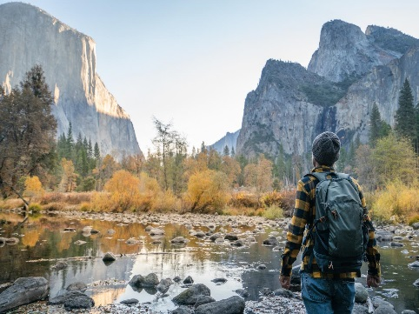

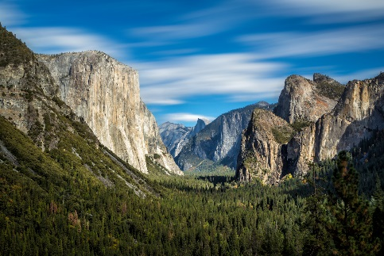

What is the Yosemite National Park?

Yosemite National Park is located in the western Sierra Nevada of Central California. It covers an area of 748,436 acres (1,169 square miles).

Designated a World Heritage site in 1984, Yosemite is internationally recognized for its granite cliffs, waterfalls, clear streams, giant sequoia groves, lakes, mountains, meadows, glaciers, and biological diversity. Almost 95% of the park is designated wilderness.

Facts About the Mountain Range:
- On average, about four million people visit Yosemite each year, and most spend the majority of their time in the seven square miles (18 km2) of Yosemite Valley. The park set a visitation record in 2016, surpassing five million visitors for the first time in its history.
- Concerned by the effects of commercial interests, prominent citizens including Galen Clark and Senator John Conness advocated for protection of the area. A park bill was prepared with the assistance of the General Land Office in the Interior Department. The bill passed both houses of the 38th United States Congress, and was signed by President Abraham Lincoln on June 30, 1864, creating the Yosemite Grant. This is the first instance of park land being set aside specifically for preservation and public use by action of the U.S. federal government, and set a precedent for the 1872 creation of Yellowstone as the first national park. Yosemite Valley and the Mariposa Grove were ceded to California as a state park, and a board of commissioners was proclaimed two years later.
- Tourism significantly increased after the First Transcontinental Railroad was completed in 1869, but the long horseback ride to reach the area was a deterrent.[30] Three stagecoach roads were built in the mid-1870s to provide better access for the growing number of visitors to Yosemite Valley.
- John Muir was a Scottish-born American naturalist and explorer. It was because of Muir that many National Parks were left untouched, such as Yosemite Valley National Park. One of the most significant camping trips Muir took was in 1903 with then president Theodore Roosevelt. This trip persuaded Roosevelt to return "Yosemite Valley and Mariposa Grove to federal protection as part of Yosemite National Park".

The Wawona Tree

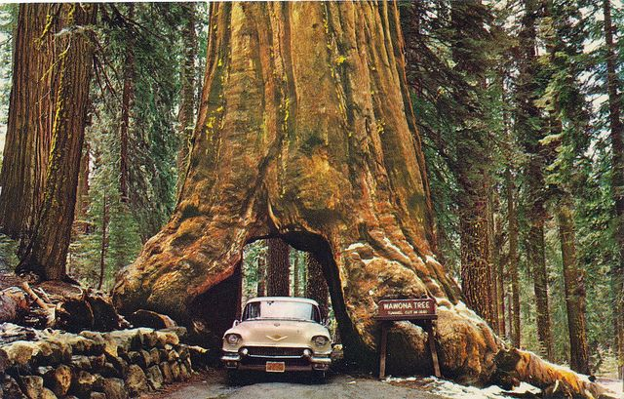
Also known as the Tunnel Tree, was a famous giant sequoia that stood in the Mariposa Grove. It was 227 feet (69 m) tall, and was 90 ft (27 m) in circumference. When a carriage-wide tunnel was cut through the tree in 1881, it became even more popular as a tourist photo attraction. Everything from horse-drawn carriages in the late 19th century, to automobiles in the first part of the 20th century, traveled the road which passed through that tree. The Wawona Tree fell in 1969 under a heavy load of snow. It was estimated to have been 2,300 years old.

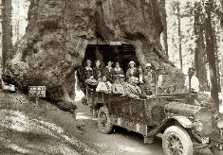

- Almost all of the landforms in the Yosemite area are cut from the granitic rock of the Sierra Nevada Batholith (a batholith is a large mass of intrusive igneous rock that formed deep below the surface). About 5% of the park's landforms (mostly in its eastern margin near Mount Dana) are metamorphosed volcanic and sedimentary rocks. These rocks are called roof pendants because they were once the roof of the underlying granitic rock.
- Erosion acting upon different types of uplift-created joint and fracture systems is responsible for creating the valleys, canyons, domes, and other features we see today. These joints and fracture systems do not move, and are therefore not faults.
- El Capitan, a prominent granite cliff that looms over Yosemite Valley, is one of the most popular rock climbing destinations in the world because of its diverse range of climbing routes in addition to its year-round accessibility. Granite domes such as Sentinel Dome and Half Dome rise 3,000 and 4,800 feet (910 and 1,460 m), respectively, above the valley floor. In the park are many domes.
- The park has three groves of ancient giant sequoia (Sequoiadendron giganteum) trees; the Mariposa Grove (200 trees), the Tuolumne Grove (25 trees), and the Merced Grove (20 trees). This species grows larger in volume than any other and is one of the tallest and longest-lived.
- Yosemite is famous for its high concentration of waterfalls in a small area. Located in Yosemite Valley, the Yosemite Falls is the highest in North America at 2,425 feet.
- All glaciers in the park are relatively small glaciers that occupy areas that are in almost permanent shade. None of the Yosemite glaciers are a remnant of the much, much larger Ice Age alpine glaciers responsible for sculpting the Yosemite landscape.

Yosemite National Park Black Bears

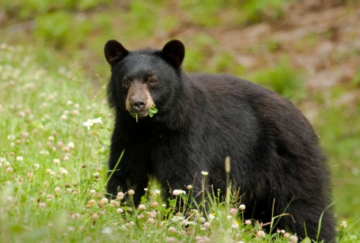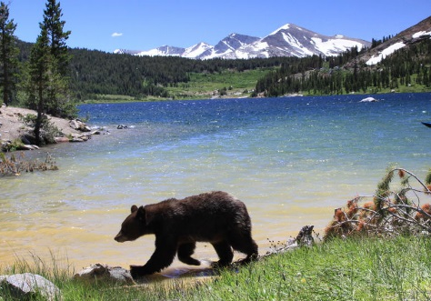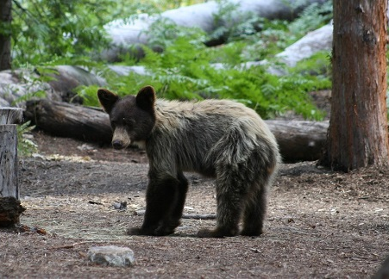

The black bears of Yosemite were once famous for breaking into parked cars to steal food. They were also an encouraged tourist sight for many years at the park's garbage dumps, where bears congregated to eat park visitors' garbage and tourists gathered to photograph the bears. Increasing encounters between bears and humans and increasing damage to property led to an aggressive campaign to discourage bears from relying on human food or interacting with people and their property.

The open-air dumps were closed; all trash receptacles were replaced with bear-proof receptacles; all campgrounds were equipped with bear-proof food lockers so that people would not leave food in their vehicles, which were easy targets for the powerful and resourceful bears. Because bears who show aggression towards people usually are eventually destroyed, park personnel have continued to come up with innovative ways to have bears associate humans and their property with unpleasant experiences, such as being hit with rubber bullets.

Today, about 30 bears a year are captured and ear-tagged and their DNA is sampled so that, when bear damage occurs, rangers can ascertain which bear is causing the problem.

