Zion National Park
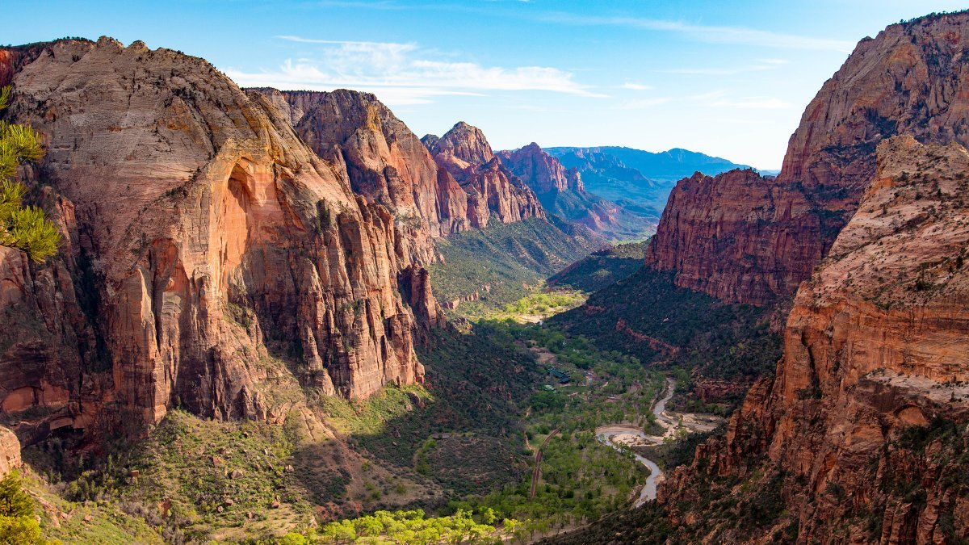

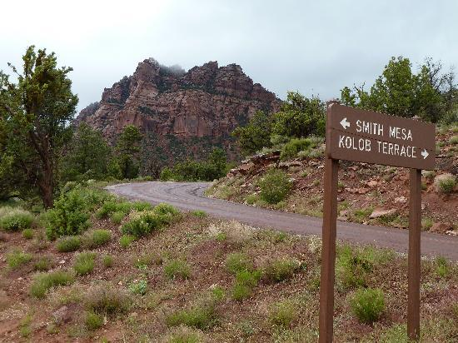

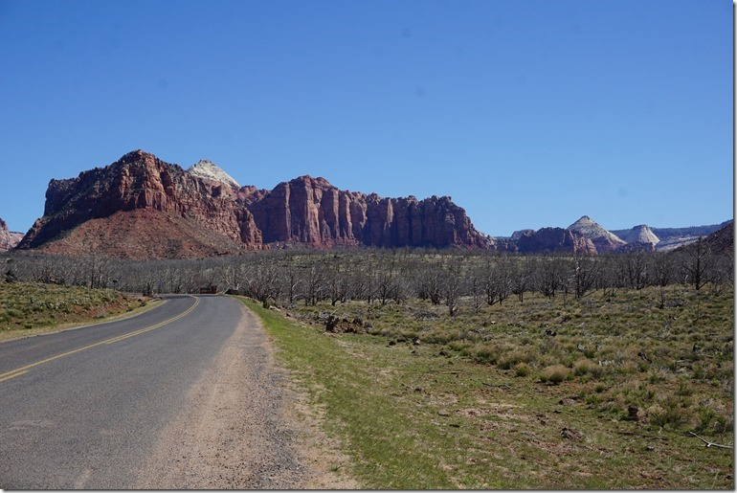

What is the Zion National Park?

Is an American national park located in southwestern Utah. A prominent feature of the 229-square-mile park is Zion Canyon, which is 15 miles long and up to 2,640 ft deep. The canyon walls are reddish and tan-colored Navajo Sandstone.

Facts About the Mountain Range:
- Located at the junction of the Colorado Plateau, Great Basin, and Mojave regions, the park has a unique geography and a variety of life zones that allow for unusual plant and animal diversity. Numerous plant species as well as 289 species of birds, 75 mammals (including 19 species of bat), and 32 reptiles inhabit the park's four life zones: desert, riparian, woodland, and coniferous forest. Zion National Park includes mountains, canyons, buttes, mesas, monoliths, rivers, slot canyons, and natural arches.
- Human habitation of the area started about 8,000 years ago with small family groups of Native Americans, one of which was the semi-nomadic Basketmaker Anasazi (c. 300 CE). Mormons came into the area in 1858 and settled there in the early 1860s.
- In 1918, the acting director of the newly created National Park Service, Horace Albright, drafted a proposal to enlarge the existing park and change the park's name to Zion National Monument, Zion being a term used by the Mormons. According to historian Hal Rothman: "The name change played to a prevalent bias of the time. Many believed that Spanish and Indian names would deter visitors who, if they could not pronounce the name of a place, might not bother to visit it. The new name, Zion, had greater appeal to an ethnocentric audience."
- The Kolob Terrace area, northwest of Zion Canyon, features a slot canyon called The Subway, and a panoramic view of the entire area from Lava Point. Other notable geographic features of Zion Canyon include Angels Landing, The Great White Throne, the Court of the Patriarchs, The West Temple, Towers of the Virgin, the Altar of Sacrifice, the Watchman, Weeping Rock, and the Emerald Pools.
- Common daytime animals include mule deer, rock squirrels, pinyon jays, and whiptail and collard lizards. Desert cottontails, jackrabbits, and Merriam's kangaroo rats come out at night. Cougars, bobcats, coyotes, badgers, gray foxes, and ring-tail cats are top predators.
- Nineteen species of bat also live in the area.

Zion National Park Birds

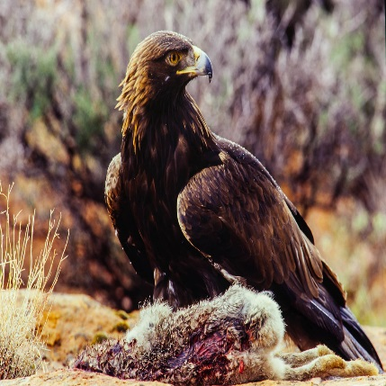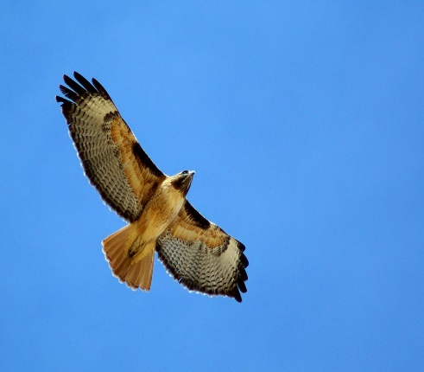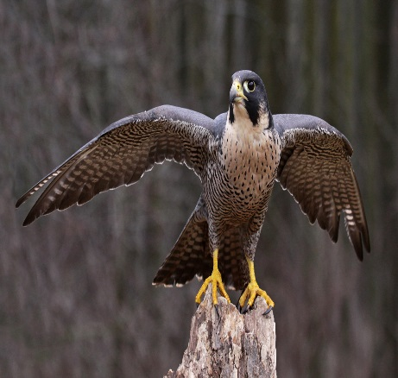
Golden Eagle Red-tailed Hawk Peregrine Falcon

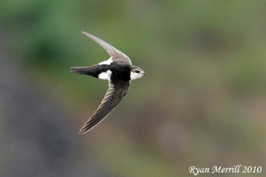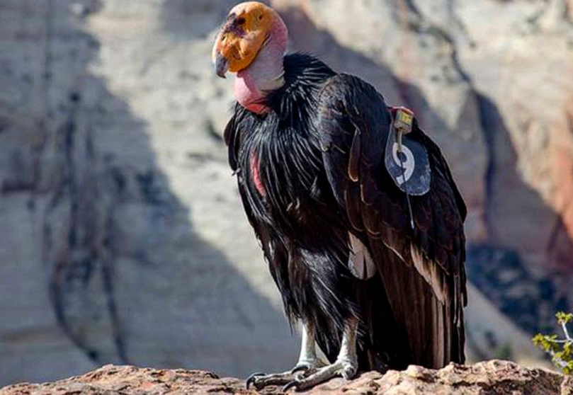
White-throated Swifts California Condor

Golden eagles, red-tailed hawks, peregrine falcons, and white-throated swifts can be seen in the area.
California condors were reintroduced in the Arizona Strip and in 2014 the first successful breeding of condors in the park was confirmed.

